**[F29DC 2024 Lab 3 -](https://canvas.hw.ac.uk/courses/28951/files/3694381?wrap=1" \o "F29DC 2024 Lab 1 - Connectivity, VPCs, Subnets, VLANs.pdf" \t "_blank) Routing  
- Shyam Sundar Velmurugan  
- H00418621**

{Part 1}

Topology configuration

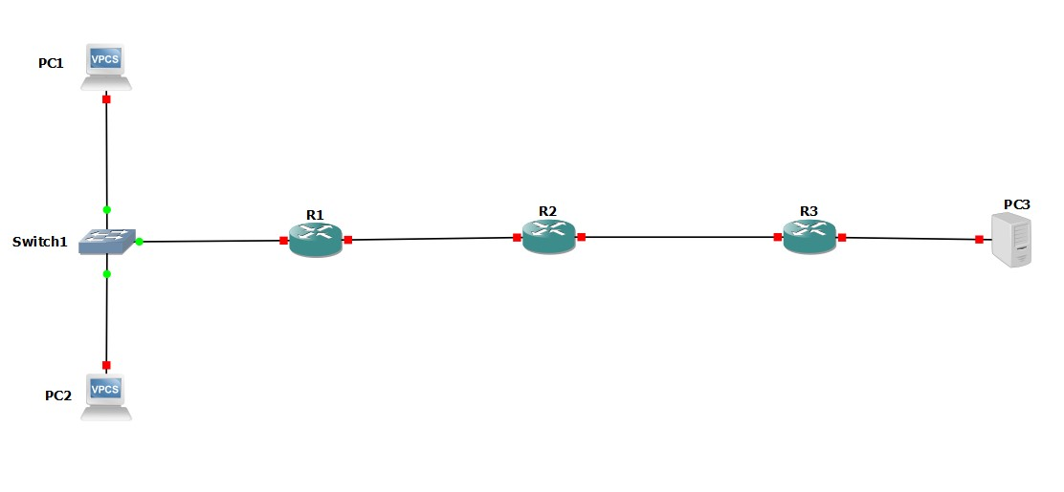

Image 1.1 : setting up connections between PC1, PC2, and PC3 with R1, R2, R3

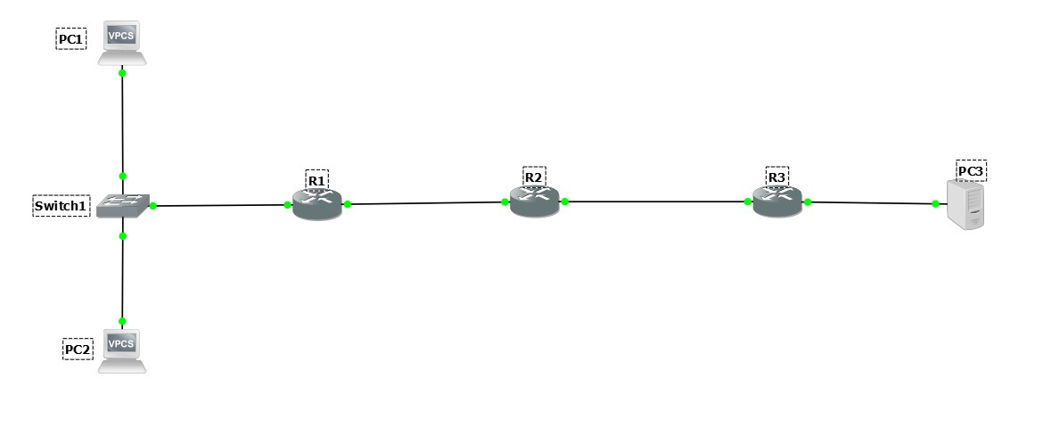

Image 1.2 : Starting all the connections

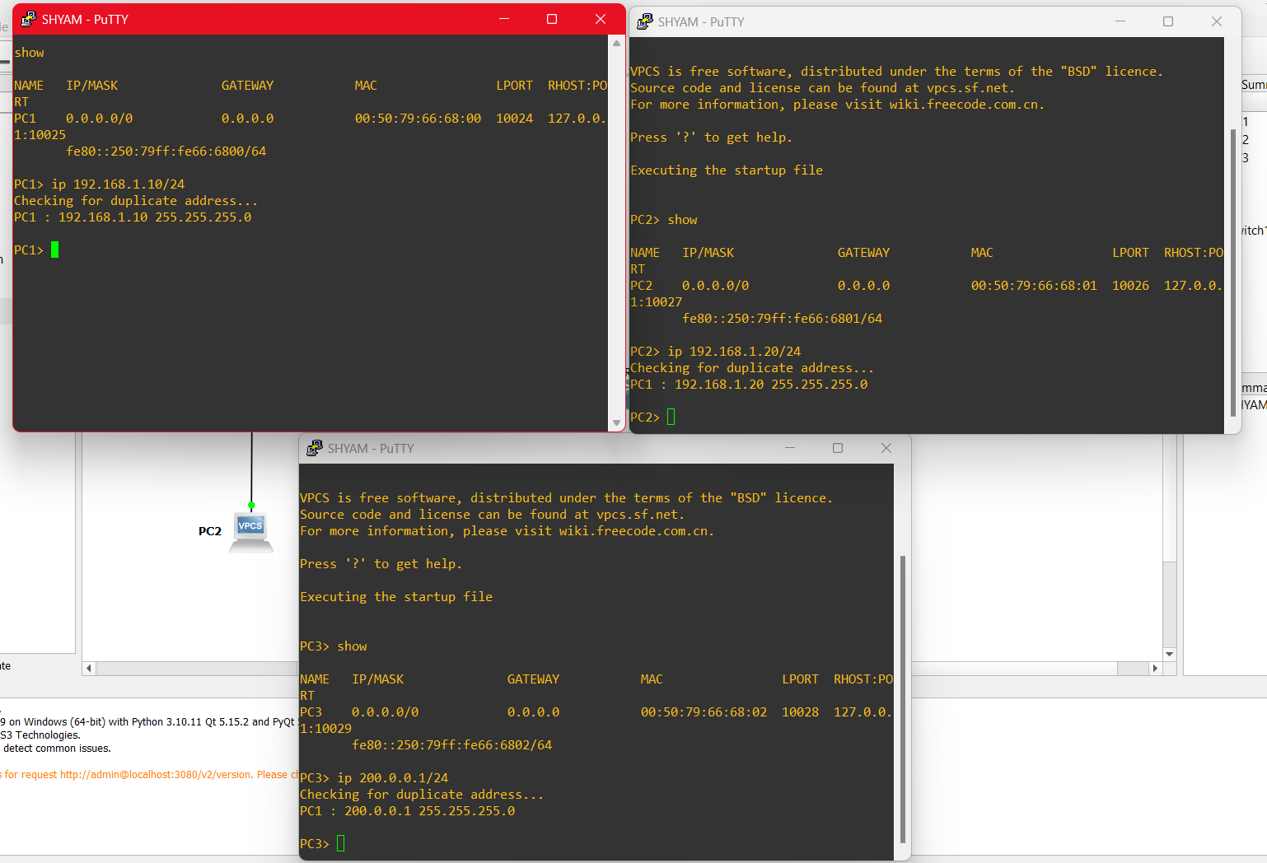

Image 1.3 : providing IP address for all VPC’S as follows

VPC 1 = 192.168.1.10/24

VPC 2 = 192.168.1.20/24

VPC 3 = 200.0.0.1/24

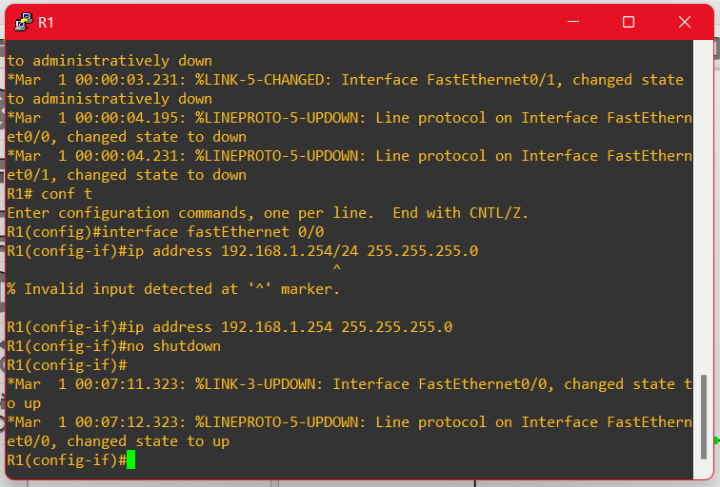

Image 1.4 : setting up R1 with fast ethernet 0/0 and with ip address 192.168.1.254 255.255.255.0

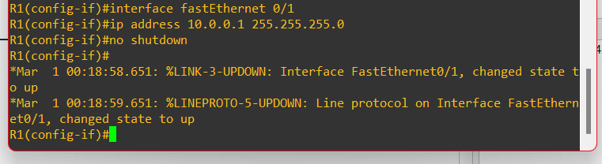

Image 1.5 : setting up R1 with fast ethernet 0/1 and with ip address 10.0.0.1 255.255.255.0

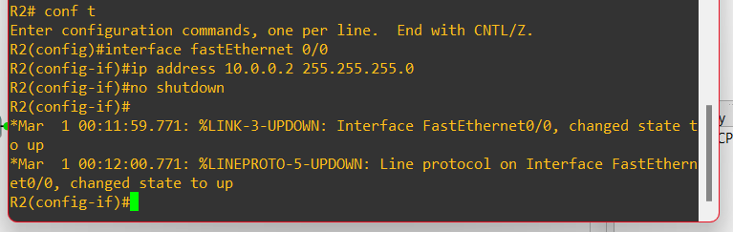

Image 1.6 : setting up R2 with fast ethernet 0/0 with ip address 10.0.0.2 255.255.255.0

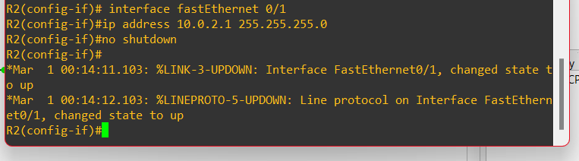

Image 1.7 : setting up R2 with fast ethernet 0/1 with ip address 10.0.2.1 255.255.255.0

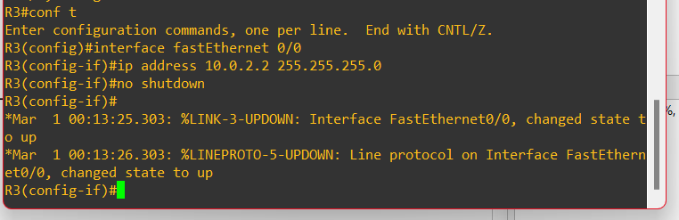

Image 1.8 : setting up R3 with fast ethernet 0/0 with ip address 10.0.2.2 255.255.255.0

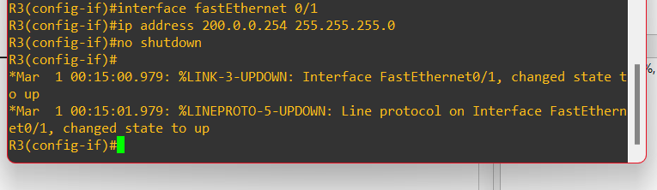

Image 1.9 : setting up R3 with fast ethernet 0/1 with ip address 200.0.0.254 255.255.255.0

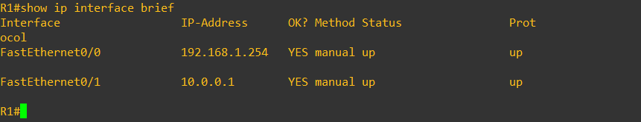

Image 1.10 : checking if we have correctly provided the ip for the R1

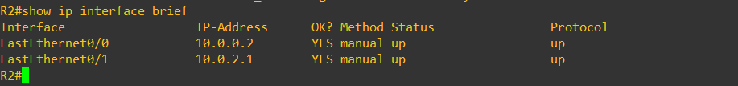

Image 1.11 : checking if we have correctly provided the ip for the R2

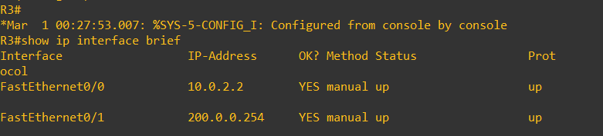

Image 1.12 : checking if we have correctly provided the ip for the R3

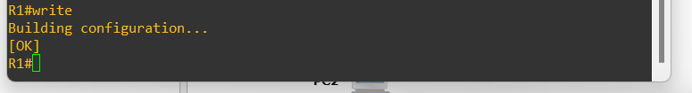

Image 1.13 : using write command for saving the ip addresses provided for R1 .

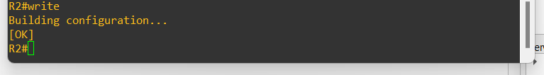

Image 1.14 : using write command for saving the ip addresses provided for R2 .

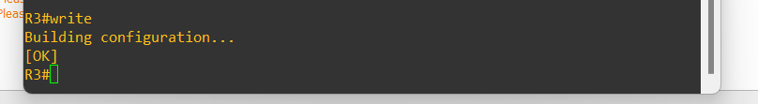

Image 1.15 : using write command for saving the ip addresses provided for R3 .